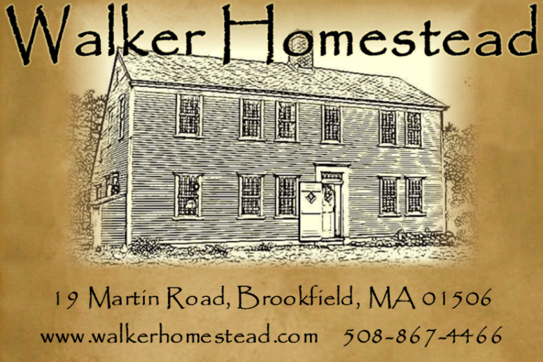
Punch Needle Fraktur Workshop with
Doreen Frost of Vermond Harvest Folk Art~

Join us for a day of punch needle embroidery with Doreen Frost of Vermont Harvest Folk Art. Doreen Frost has designed a fraktur-style punch needle pattern for us to work on (photo coming soon) and all materials are included. All participants will take home a framed punch needle piece of art suitable to hang on their wall. We will work in the Tavern Room, with a blazing fire and wonderful luncheon.

Doreen Frost spends her days, in a cozy little house in Vermont, stitching mohair bears, working on new punch needle embroidery designs, sketching and writing. Her days are simple and full. She is kept busy with a home and animals to tend, heating with wood from the property as well as maintaining large vegetable, herb and flower gardens. She preserves what she grows and they are Vermont maple sugar growers. Growing up in a creative family had a huge influence on Doreen and she feels that much of her creativity has been passed down from generations of stitchers, bakers, cooks and artists. Her inspiration comes from a long list of favorite things; children's literature (which she still reads), her animals, wild animals, a person, a bit of fabric or antique piece.

Date: Saturday, October 10, 2015 9:30 a.m. – 4:00 p.m.
Place: Walker Homestead, 19 Martin Road, Brookfield, MA 01506
Cost: $130 per person includes instruction, materials and a seasonal luncheon.

Menu
Carrot & Cheese Crustini
Hungarian Mushroom Soup
Chocolate Chip Walnut Biscotti
Hot or Cold Cider or Tea
Coffee
Schedule
9:30 a.m. – Coffee & Introductions
10:00 a.m. – Class
12:30 – Lunch
3:30 – Visit our shop & questions

REGISTRATION FORM

Event: Punch Needle Fraktur Workshop with Doreen Frost
Saturday, October 10, 2015 9:30 a.m. – 4:00 p.m.

Name: ___________________________________________________________________

Address: _________________________________________________________________
__________________________________________________________________
__________________________________________________________________

Phone: ____________________________________________________________________

E-mail: ____________________________________________________________________

Please let us know if you have any special dietary needs: _________________________________
_____________________________________________________________________________________
Event cost: $130 payable to Walker Homestead at time of registration.

(credit cards are accepted, use form below)
If paying by credit card:
Name on card: __________________________________
Card Number: ___________________________________
Expiration date: _____________ 3 digit code on back: ___________
Zip code from billing address: _____________________

Please mail this form, together with payment, to:

Walker Homestead
19 Martin Road
Brookfield, MA 01506

Thank you!

