Folk Art Painted MailboxWorkshop & Luncheon with
Renowned Rhode Island Folk Artist, Gladys Desmond, The Itinerant Painter~

Gladys Desmond, "The Itinerant Painter“, lives in Rhode Island in a 1600's farmhouse that once sheltered itinerant farm workers. She has continued in the tradition of her home by calling her business - "The Itinerant Painter". Having lived in New England all her life, with its rich abundance of history, traditional farms and landscapes, she captures and paints them in a primitive manner.
Gladys paints on antique and reproduction surfaces, as well as traveling throughout New England painting murals. Her greatest pleasure is to create a mural for someone with a little bit of their own life in it - their cat sitting on a tree branch, their children in colonial clothing playing with barrel hoops, an old historical school they attended as children, anything meaningful to them. She combines the past and the present with a few brushstrokes.

Date: Saturday, January 24, 2015 9:30 a.m. – 4:00 p.m.
Place: Walker Homestead, 19 Martin Road, Brookfield, MA 01506
Cost: $95 per person includes instruction, materials, pattern and seasonal lunch.
Each participant will complete an a folk art painted mailbox to take home.
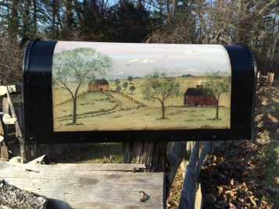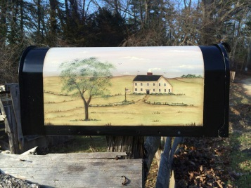
Menu
Fruit & Cheese plate
Potato Leek Soup
Chicken Cutlet Parmesan with
Tomato Sauce & Pasta
Chocolate Chip Walnut Biscotti
Hot or Cold Cider
Hot or Cold Tea
Coffee
Schedule
9:30 a.m. – Coffee & Introductions
10:00 a.m. – Class
Noon – 15 minute break
12:15 – Lunch
1:00 – Class Resumes
2:15- Snack
3:45 – Visit our shop & questions
REGISTRATION FORM

Event: January Workshop & Luncheon with Gladys Desmond~
Saturday, January 24, 2015 9:30 a.m. – 4:00 p.m.

Name: ___________________________________________________________________

Address: _________________________________________________________________
__________________________________________________________________
__________________________________________________________________

Phone: ____________________________________________________________________

E-mail: ____________________________________________________________________

Please let us know if you have any special dietary needs: _________________________________
_____________________________________________________________________________________
Event cost: $95 payable to Walker Homestead at time of registration.

(credit cards are accepted, use form below)
If paying by credit card:
Name on card: __________________________________
Card Number: ___________________________________
Expiration date: _____________ 3 digit code on back: ___________
Zip code from billing address: _____________________

Please mail this form, together with payment, to:

Walker Homestead
19 Martin Road
Brookfield, MA 01506

Thank you!

